Ideation Phase
Define the Problem Statements

Date | 25 October 2026
Team ID:
Project Name | StaffSync
Maximum Marks | 2 Marks

Customer Problem Statement Template:
To define the core administrative and collaboration challenges organizations face in managing workforce records, attendance, and leave workflows, and use those insights to guide the development of StaffSync.
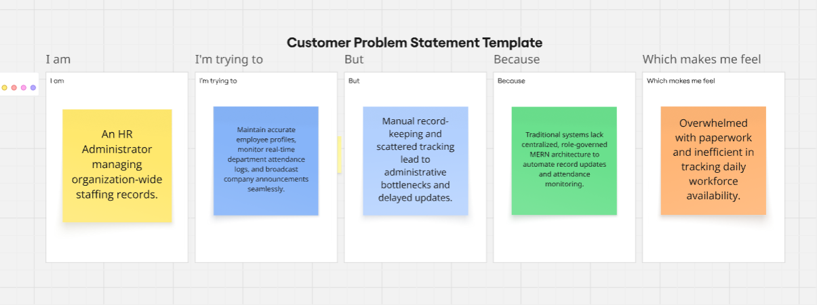
Reference: https://miro.com/templates/customer-problem-statement/

Problem Statement (PS) | I am (Customer) | I’m trying to | But | Because | Which makes me feel
PS -1 | An HR Administrator managing organization-wide staffing records. | Maintain accurate employee profiles, monitor real-time department attendance logs, and broadcast company announcements seamlessly. | Manual record-keeping and scattered tracking lead to administrative bottlenecks and delayed updates. | Traditional systems lack centralized, role-governed MERN architecture to automate record updates and attendance monitoring. | Overwhelmed with paperwork and inefficient in tracking daily workforce availability.
PS-2 | An employee applying for planned leaves and tracking attendance. | Submit time-off requests specifying dates/reasons, view approval statuses, and read organization bulletin notices. | Lack of transparent tracking leaves me uncertain about remaining leave balances or request approvals. | Manual approval workflows lack instant status updates or self-service employee dashboards. | Frustrated by the lack of transparency in tracking my workplace requests.
PS-3 | A Team Manager supervising departmental reporting staff. | Review, approve, or reject employee leave requests quickly while coordinating team training schedules. | Tracking leave balances and team availability manually causes communication gaps and scheduling overlaps. | There is no centralized portal providing real-time visibility into pending leave requests and skill development programs. | Constantly bottlenecked trying to balance team productivity and time-off coordination.

